*Revenue Models*

There are many revenue models that the firms within the film industry use. Subscriptions are seen utilized by the big-named streaming services such as Netflix, Hulu, and Amazon video in which the consumer must pay a monthly fee in order to continuously use their service. Traditional sales is another- and quite easily the most basic- form of revenue for film companies because it occurs whenever a customer buys a product or service from that company- i.e. buying a movie ticket or buying/renting a digital download of from their service. Another main form of revenue that many film firms use is advertising. This is seen most commonly with the video-sharing website YouTube. Before your video loads, another short one plays before it advertising another company’s product/service. This means that the company that the ad is displaying is paying YouTube, giving YouTube enough revenue to allow it to remain a free-to-use service. Along with advertisements, YouTube also has the Freemium feature YouTube TV. This still means that YouTube is a free service but if a consumer pays a premium charge then they have the privilege to watch the site’s exclusive content.1

*Innovation is Often Risky*

Thanks to the numerous innovations to cameras and film equipment in general, we have been able to witness an increase in film quality. A summer blockbuster that came out in 2018 will have significant improvements than that of one released in 2008. Some of the developments that these companies make has the potential to run other firms out of business. This can be seen with the marginalization of film cameras due to the widespread use of digital film cameras in the later half of the 20th century as well as camera drones minimizing the need for helicopters to get aerial shots. The decision to use a drone makes more fiscal sense because the price of a camera drone can range from $30 to about $3000 depending on the quality of the drone whereas the price to rent a helicopter ranges from about $200 to $1000 per hour.2 However, along with any innovation comes the copycats and one of the main way companies protect these is applying for patents. One recent example of a major movie company doing this is with their recent release “Spider-Man: Into the Spider-Verse”. Sony did not waste time meticulously animating every second of their work with its largest team of animators- 140 to be exact- with which the company had ever worked. And it paid off as the movie received a Golden Globe for this achievement. Now the company wants to keep a hold on their animation process and the technology that they used to ensure that no one else can replicate it exactly the way that they did.3 Innovations are an important competitive advantage in any industry and companies need to make sure that they keep theirs safe at all costs.

*Open Innovation*

From a certain perspective, every movie that a company makes is an innovation as it is a product that returns value to the organization from its sales. Open innovation is the process in which external stakeholders can have a say in the innovation process. This is seen with all kinds of different movies as the producers of the movie can have an opinion in which the direction the movie should go. Their opinions can either benefit or hurt the final product, but in the end, what they say- for the most part- has to be done because it is their money that is funding the creation after all.

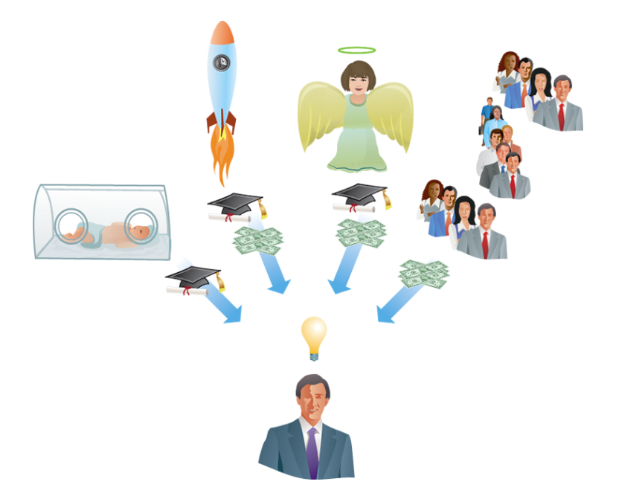

*Crowdfunding*

Crowdfunding has become a prominent way of having small-scale movies or miniseries produced. Kickstarter, Indiegogo, and Patreon have become some of the most prominent names when it comes to crowdfunding. All of these websites accomplish the objective of having a crowd-funded project being produced but the one that many YouTube creators turn to is Patreon, a subscription service that supports small creators in their endeavors to keep creating videos. Some popular examples are the high-quality education channel Crash Course, the A Capella pop singer Peter Hollens, and countless of others.4

1. Valacich, J. (2019). Information Systems Today: Managing the Digital World. 8th ed. Pearson.
2. Quora. (2019). How much does it cost to rent a helicopter for aerial photography?. [online] Available at: https://www.quora.com/How-much-does-it-cost-to-rent-a-helicopter-for-aerial-photography [Accessed 15 Feb. 2019].
3. Valera, S. (2018). Sony Seeks Patent for 'Spider-Man: Into the Spider-Verse' Animation Tech - Geek.com. [online] Geek.com. Available at: https://www.geek.com/movies/sony-seeks-patent-for-spider-man-into-the-spider-verse-animation-tech-1765786/ [Accessed 15 Feb. 2019].
4. Arnold, T. (2017). These 35 Creators Earned Over $150,000 Each on Patreon in 2016 – Meet Them! | Patreon Blog. [online] Blog.patreon.com. Available at: https://blog.patreon.com/top-earners-2016 [Accessed 17 Feb. 2019].